Guidelines for 2026 Summer Thesis/Dissertation Binding and Submission Process

Students eligible to receive a graduate degree in August 2026 must submit their thesis/dissertation as follows:

1. Please format your thesis/dissertation in accordance with the attached template.
* Note
① Please enter the submission sheet date for the thesis as " April 2026" and
the approval sheet date of thesis as " June 2026".
* Do not change the date.
② Please enter the year on the side of the cover as “2026”
③ Please use HY신명조, 휴먼명조 fonts.
If you use “Times New Roman” fonts, please increase the font size by 2P.
Good Cases Bad Cases
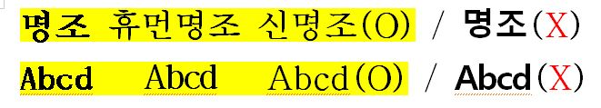
④ Please observe the fonts size, page layout.
⑤ Do not include an Acknowledgments section.
⑥ If you fail to submit your thesis/dissertation online or offline within the designated period, your graduation will be postponed to the following semester. In addition, if you also fail to submit your thesis/dissertation in the following semester, your final defense result will be cancelled, and you must apply for the final defense again.

2. ONLINE SUBMISSION

A. Period: ~ July 3, 2026, 17:00 (KST)
B. How to submit (Refer to the Attachment)
1) Please go to the relevant website of http://dcollection.skku.edu
2) Click the Submission of materials button on the blue box.
3) Login the site with ID and Password (the same as Kingo Portal ID and Password)
4) Upload your PDF (or MS-Word) formatted thesis/dissertation.
※ Please include the Thesis/Dissertation Approval sheet with all names and signatures removed of Advisory Committee members.
5) To ensure timely approval, please complete your online submission at least one day prior to the offline submission deadline.
Online Thesis/Dissertation Approval sheet
(without any names and signatures)
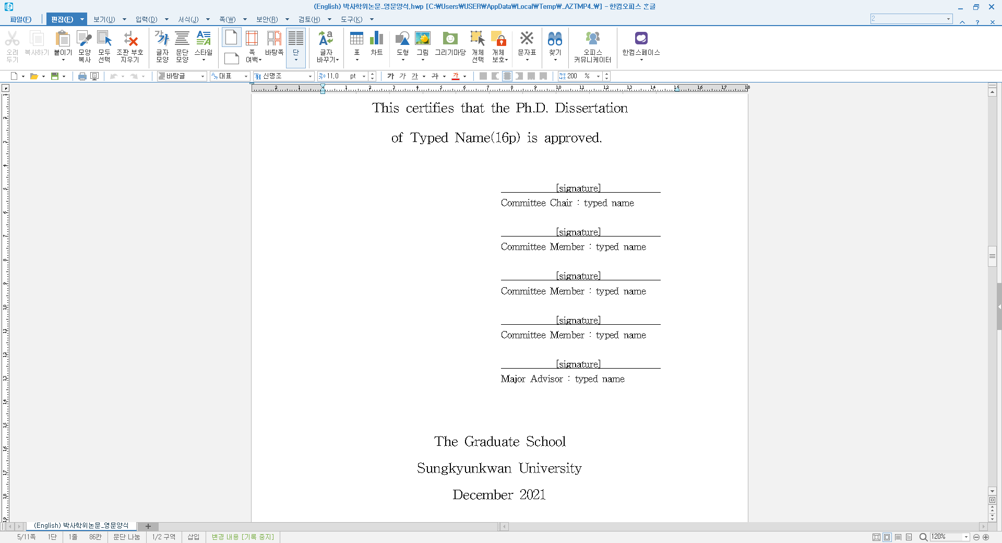

3. OFFLINE SUBMISSION
A. Period: ~ July 14, 2026, 17:00 (KST)
B. Where to submit: (※ Please be sure to wear a mask when visiting the office)
General/Special/Professional Graduate School : Administration Office of Graduate School
C. How to submit
1) Prepare three copies of your hardcover or softcover thesis/dissertation for offline submission.
- 1 copy : with the original Thesis/Dissertation Approval sheet signed by all members of the Advisory Committee(containing both of names & signatures).
- 2 copies : with the blanked Thesis/Dissertation Approval sheet without name/signatures.
※ Hardcover is available only with Navy (짙은 네이비 포크로스) cover and letters in gold.(금박)
※ Softcover is available only with White(백색 모조지) cover and letters in black.
2) Please submit the thesis/dissertation with the following documents
① (Required) Confirmation of Thesis/Dissertation Contents Consistency(학위논문 내용 일치 확인서) ※ It is possible to use the attached form.
② (Required) Online submission certificate(학위논문 전자파일 제출 확인서)
※ It is possible to print out after approval from online submission site. (dCollection)
③ (Only Ph.D) Visit the website (http://www.narastat.kr/emdh) & respond the Questionnaire, submit the “Questionnaire Completion form” (Refer the below detailed information)
④ (Only in the case If you need) Apply postponement of thesis/dissertation release
※ If you need postponement of thesis/dissertation release, please apply as follows:
Fill the form and obtain the signature of advisor and the Department Chair
▶ Apply through GLS System and upload the form
▶ Submit the original document with your thesis/dissertation to the Office of Academic Services
※ menu: GLS- 신청/자격관리>학위논문공개유예신청>학위논문비공개(공개유예)신청

OFFLINE 1 copy with name/signatures | OFFLINE 2 copies without name/signatures
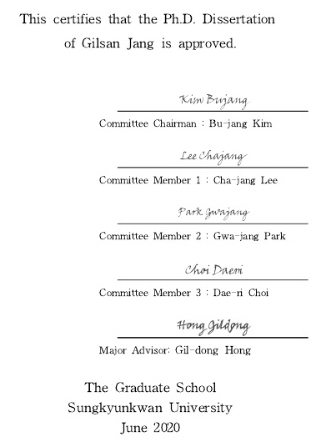 | 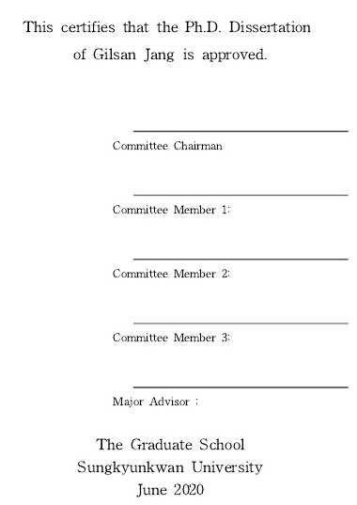

4. Questionnaire for 2026 Ph.D. Graduates (Ph.D. Only)
Students who are eligible to be conferred a graduate degree in August 2026 should submit questionnaire as follows (The questionnaire is organized by the Ministry of Education.)
1. Subject : Ph.D. Graduates(Including CMP) in August of 2026
2. Period : ~ July 14, 2026, 17:00PM
3. How to Submit :
Respond to the survey at the following website (http://www.narastat.kr/emdh), print the
Questionnaire Completion Form, and submit it together with your printed thesis/dissertation
copies to the Office of Academic.

* For more information on thesis/dissertation submission, please feel free to contact us as below.
- Online Submission: Samsung Library Office 031-299-4034, 4025
- Offline Submission: 1811-8585

